Ramon Alvarado
CS 340 Project Two

README

This project is an interactive dashboard that has the purpose of interacting with the animal data provided. Interactions include visual and geographical data of each animal, tables and filter options for the many columns, including several curated filters for various operations that could involve the need for animals. This was done through a Python-based dashboard that connects with a local MongoDB database, combined with Dash. In the case of the this project, we are using the database of the Austin Animal Center. The tools that were used, starting with MongoDB, was used in the creation of the main animal database, Python for the CRUD logic and the dashboard functionality, and PyMongo for the Python and Mongo connection. Smaller tools that were important in the development of this application include Dash for the dashboard interactivity, and Pandas for organizing the data.

The application starts off in a default state, showing a small subset of the database of animals with the added option to filter any of the given column or columns. Below that is a pie chart of the preferred animals on the left and a geolocation chart containing the animals location on the right. To the top is the logo for Grazioso Salvare, an multi national animal training company, and the company that has contracted us. On the bottom of the application is not only the credit of the developer, but also the credit for the given dataset, the Austin Animal Center. Finally, between the top logo and the table, lies the drop down menu, containing one of three pre-selected filters, corresponding with one of three potential scenarios, one for water rescues, one for mountain and wilderness rescues, and one for tracking. Once a rescue filter is selected, an “X” will appear on the right of the drop down. Pressing that will reset the filters and the drop down to its original, default state. In addition to the dataset itself, MongoDB also has access to the user login with read and write access to the animal database. Most of the main read, write, queries and deletion functions are included in the included CRUD script, which is integral to the functionality of the application.

The first two steps of the whole process, if we are dealing with the timeline of development, began with the development of the animal database, through MongoDB, from the importing of the animal dataset, to the creation of the user and password setup that will be used for the duration of, and is included in the application itself. Next is the CRUD module that has the and functions needed for interacting with the database through Python. These include, in addition to the standard CRUD functions, has to have the animal database information, including the username and password. Test scripts should be done to ensure that the CRUD functions, and the database are properly working, especially the database. From that, the dashboard itself is started, starting with the table itself and a method of connection to the CRUD module and the database. Ensure that the the connection between the CRUD module, the database, and the dashboard are also functional. From that, we can further expand that to include the geolocation chart, the pie chart, and the drop down containing the curated filters pertaining to the rescue/tracking scenarios that were requested. Finally, a thorough testing and debugging of the systems to ensure that everything is functional without issues will be needed, including ensuring the drop downs call back to the filters properly.

I had ran into several issues throughout the course of development, one of the biggest issues was the database not loading properly. This came early on in development, one was that the table wouldn’t load the database at all, showing nothing. Well, some quick test scripts showed that, while the database was showing, the table wasn’t picking up said dataset and putting it on the table. That had been sorted out with some minor modification of the CRUD module itself, the query field in particular, the table functioned as intended. Some other issues also included the main image not loading properly, something that was my own fault since I had encoded it and forgot to decode it when the time came to decode the image. There was another issue I had concerning how to actually execute the need for a reset button, since having a reset option would have the unintended side effect of possibly keeping the option visible while the whole database returned to its original state, pretty much defeating the purpose of returning the dashboard to its original state. To solve this, I had set the dropout to be clearable, so that way, once a filter is in place, it can be cleared and the intended effect of a default state occurs. Lastly, there were some glitches with the pie chart and some other minor errors as well, but with a change of pie chart variant, the chart got dealt with easily. As for the errors that kept popping up, they kept popping up as the graph updated, that had to do with the update_style logic, so I had added some parameters for having nothing in the selected column.

Resources

https://plotly.com/python/pie-charts/ - Pie chart mechanism

https://dash.plotly.com/pattern-matching-callbacks – drop down callback

https://dash.plotly.com/datatable/callbacks – data table

https://dash.plotly.com – Dash Python

https://www.mongodb.com/docs/ - MongoDB

https://www.mongodb.com/docs/languages/python/pymongo-driver/current/get-started/ - PyMongo

Screenshots

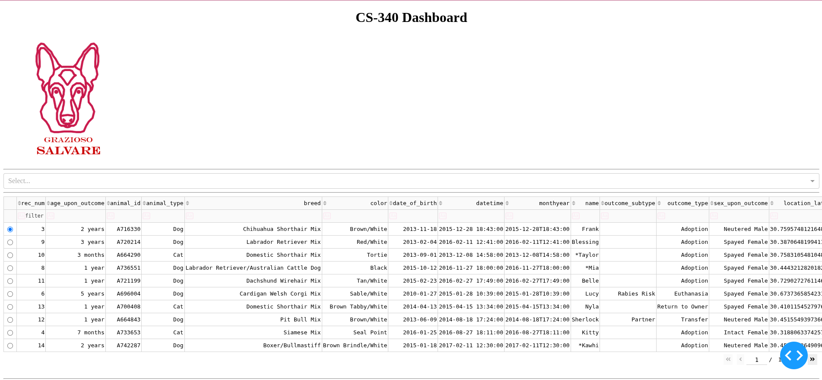

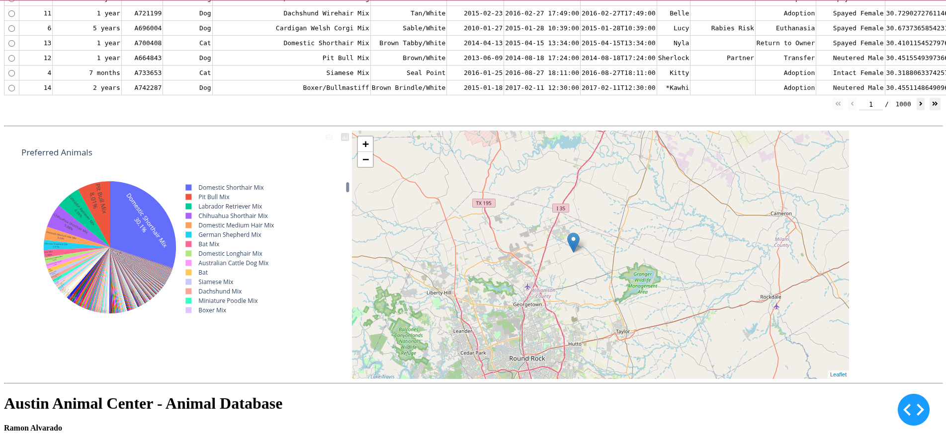
Default state

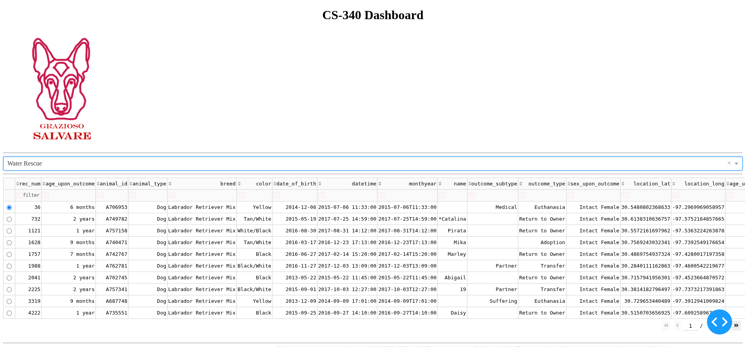
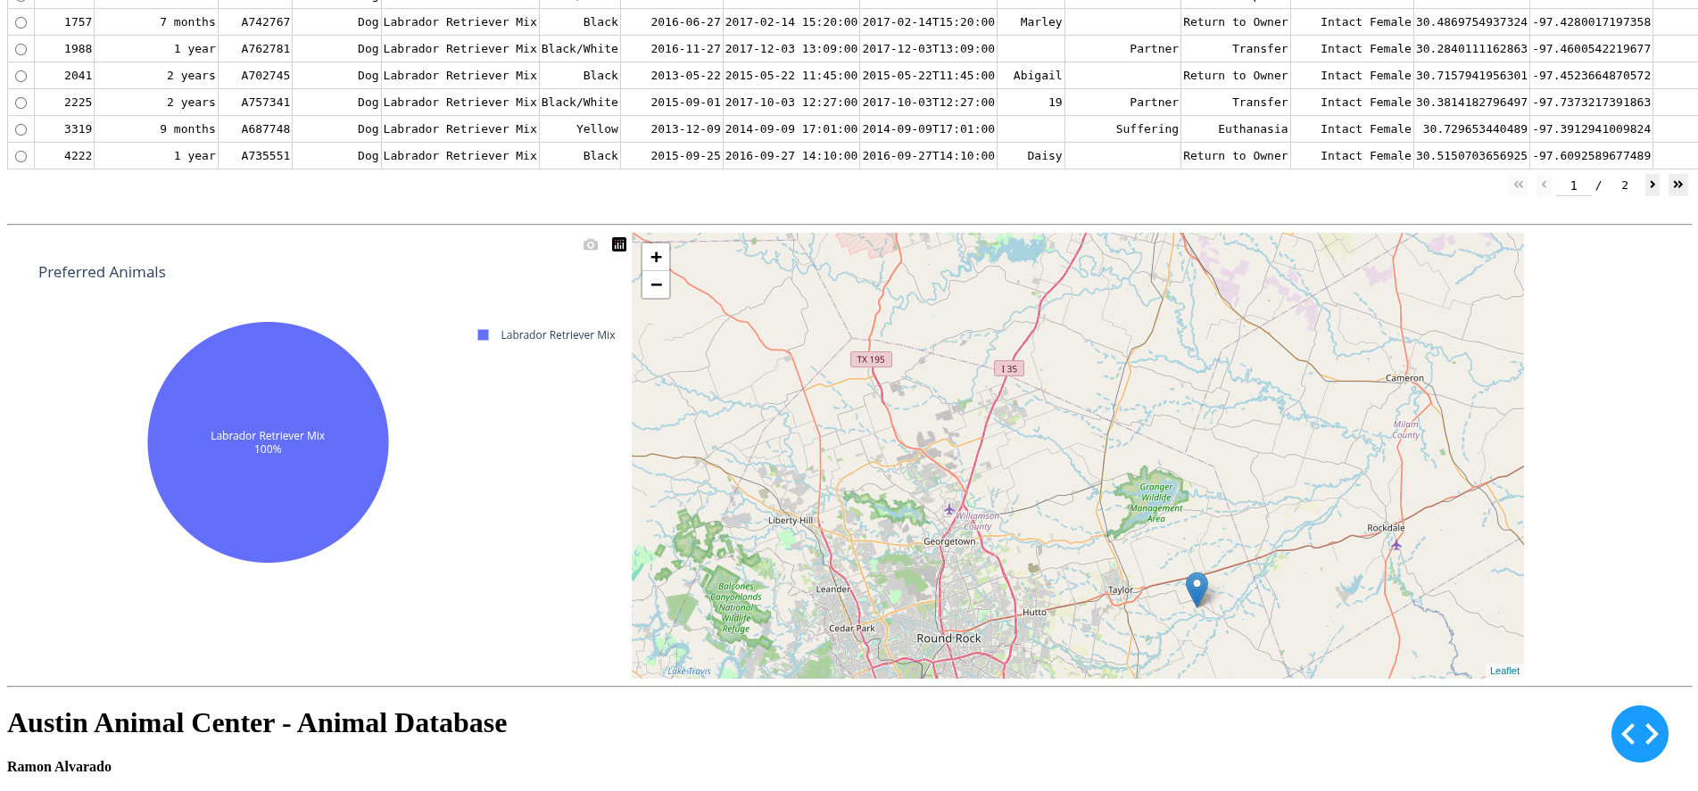
Water filter

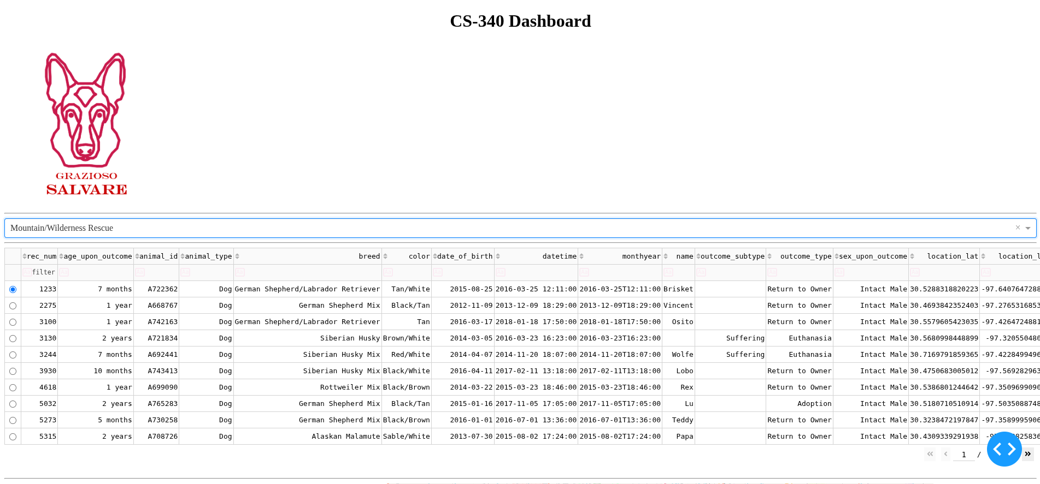
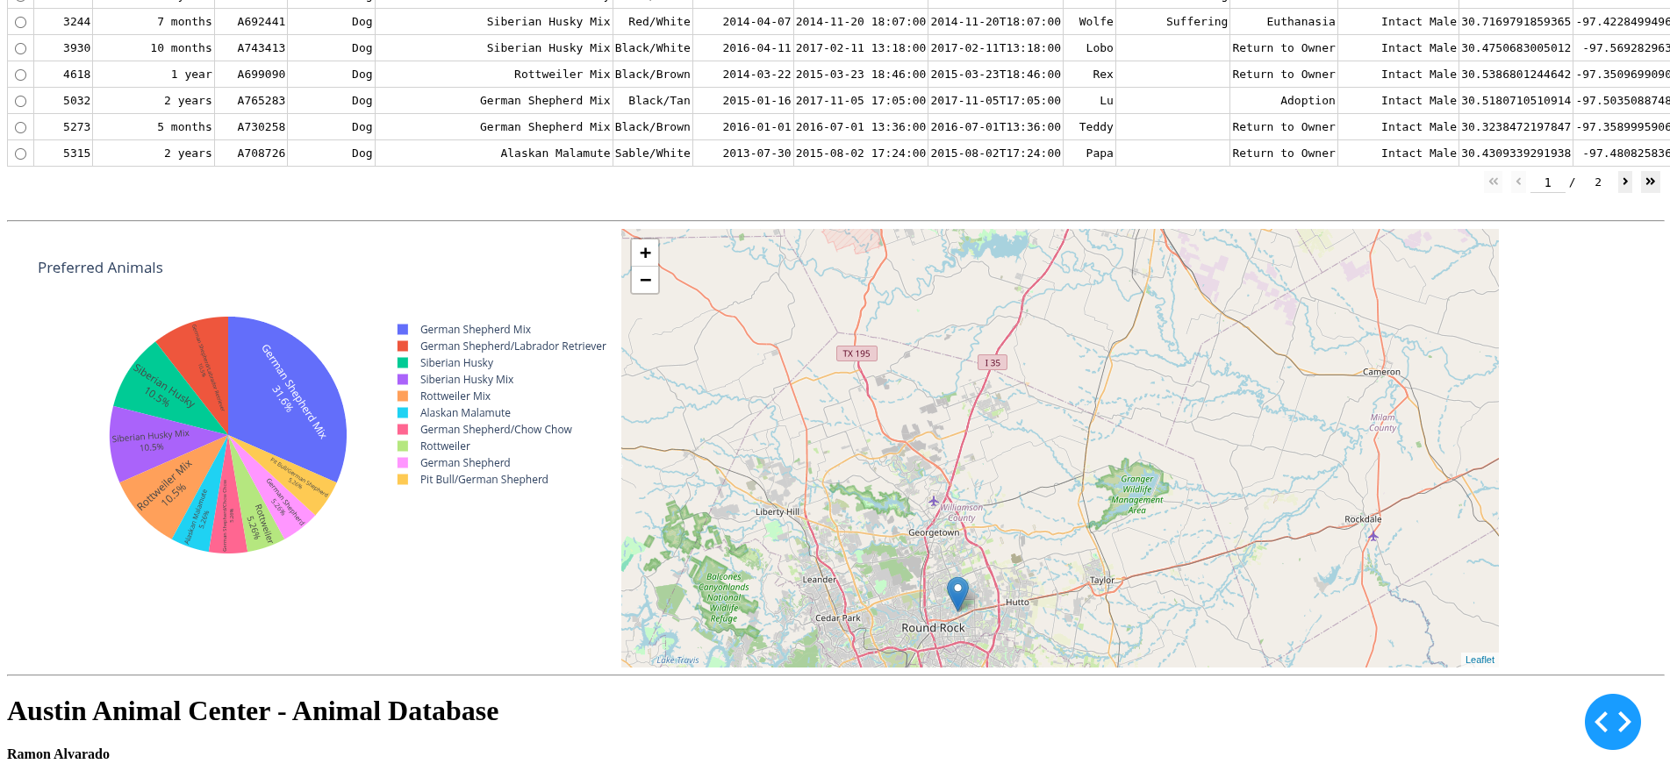
Mountain/Wilderness filter
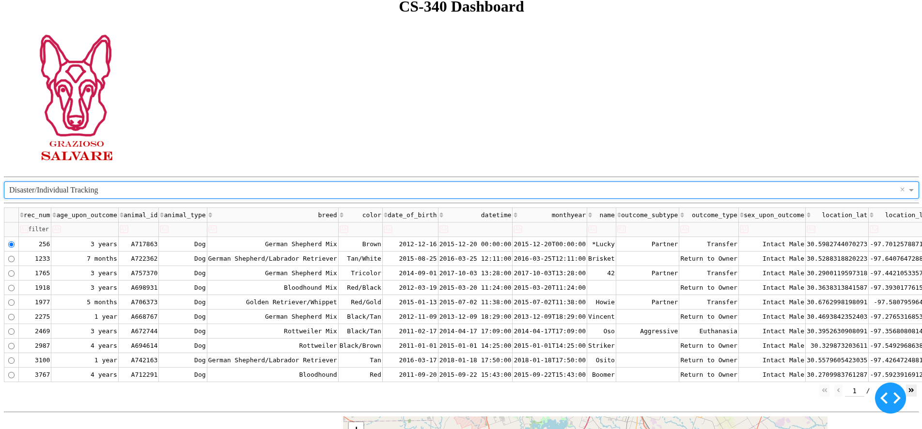
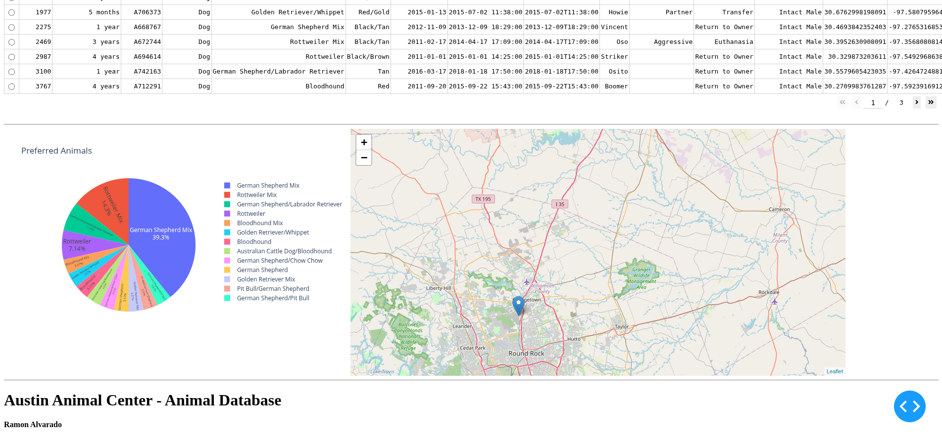

Tracking filter

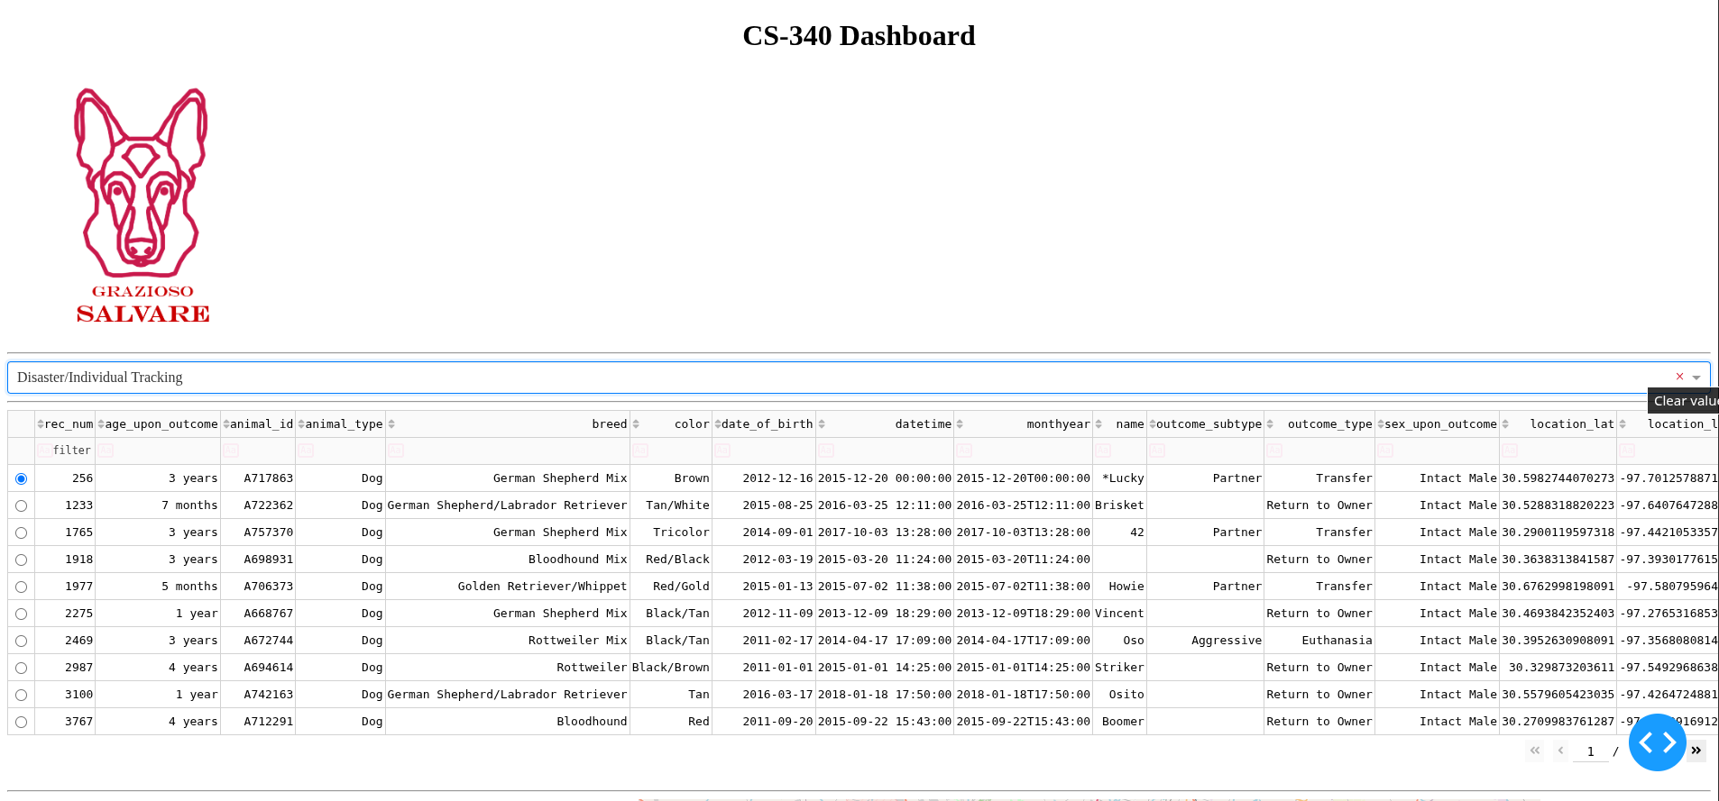
Clear Button (before press)

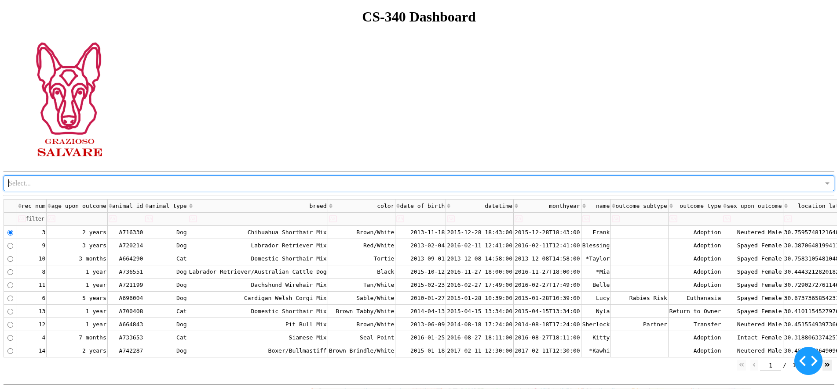

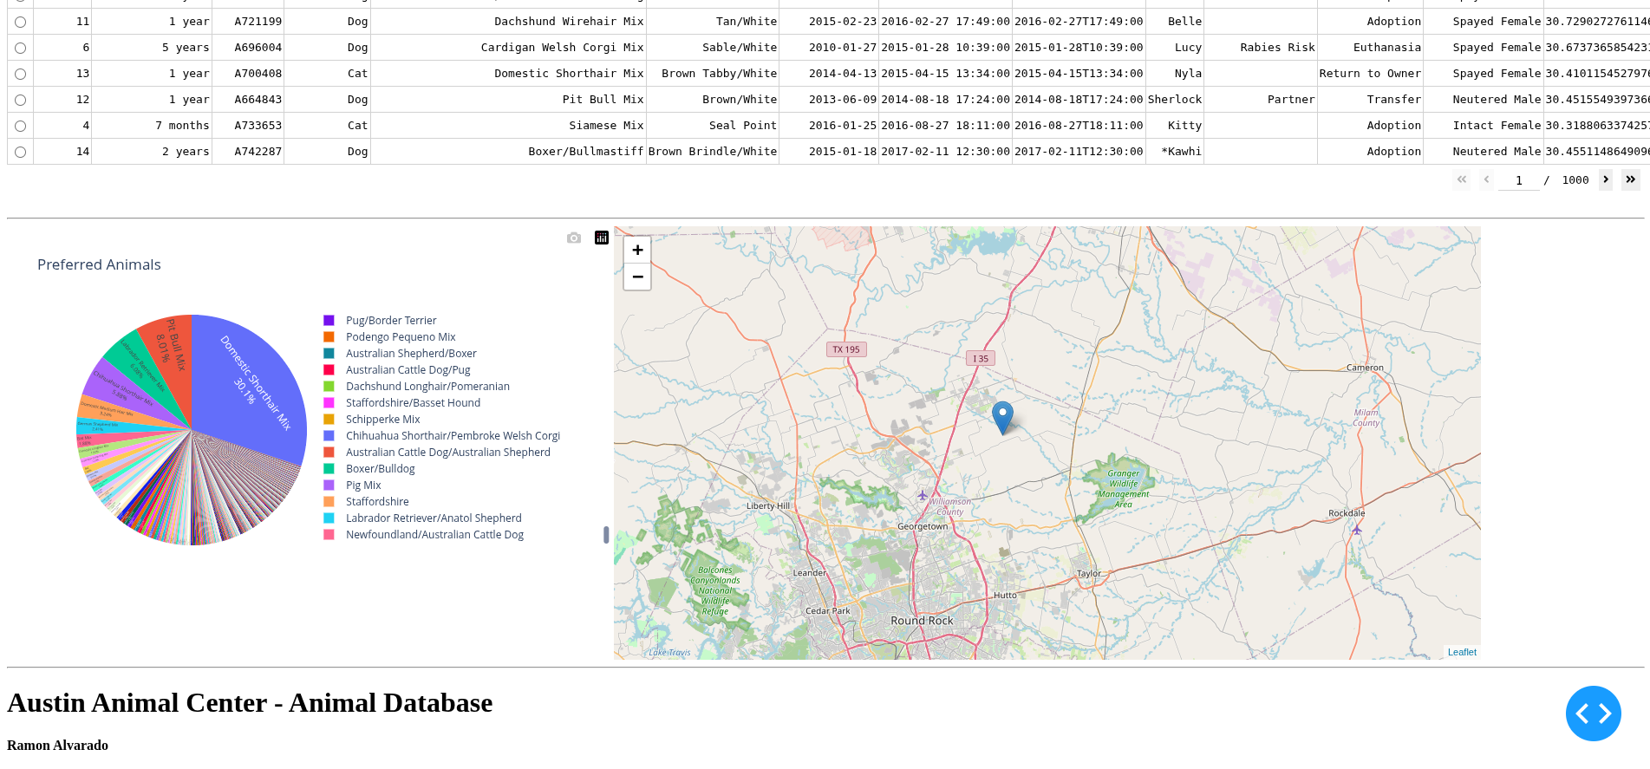
Clear button (post-press)

